**e-Project Document**

**Aquarium**

|  |  |
| --- | --- |
| **Group 2** | |
|  |  |
| **Instructor** | Mr. Nguyen Ho Long Hai |
| **Group Members** | Tran Quang Duy (Leader)  Dang Quang Chien  Nguyen Thi Thao Nguyen  Nguyen Huu Hoang Phong  Tran Van My |
| **Batch** | 140 |
| **Semester** | 1 |

**TEACHER’S EVALUATION**

**MENU**

I. ACKNOWLEDGEMENTS 5

II. INTRODUCTION 6

III. PROBLEM DEFINITION 6

1. Homepage 6

2. News page 6

3. News detail page 7

4. Buy ticker 7

5. Checkout information 7

6. Discovery 7

7. Contact Online 7

8. Contact/Support Page 7

9. Social Network 8

IV. CRS & SITE MAP 8

1. Customer Requirement Specification (CRS) 8

2. Use case diagram 10

V. PROJECT PLANNING 12

VI. GUI PROTOTYPE 14

VII. TECHNICAL 19

VIII. REFERENCES 19

IX. GUI OF WEBSITE 21

X. CHECK LIST 28

1. Check List of Validation 28

2. Submission Checklist 28

XI. CONCLUTION 29

# I. ACKNOWLEDGEMENTS

We would like to sincerely acknowledge the kindness of all the people who have given moral support and helped us make a successful project.

We wish to express our deep gratitude to the e-Project Team at the Head office, who guided and helped us. Particular thanks to **Mr.Nguyen Ho Hai Phong** who suggested the “form validation” and help us connect storage to our project, develop the analysis proceeding from it and debugged code. We also would like to express our great gratitude to all the student members of our center (Softech Aptech).

Although we have made many attempts, because of the limited time, the practice could not be able to avoid the mistakes and missions. We hope that the our project will be considered and evaluated. And finally, we would like to offer many thanks to all our friends for their valuable suggestions and constructive feedbacks.

# II. INTRODUCTION

Fish keeping is a popular fad: almost people from all the age groups like to keep fish in their home, offices etc for decoration purpose or as a hoppy. Fish keeping is itself an industry which comes in agriculture.

Currently, the tourism industry in Viet Nam is developing strongly in accordance with vnexpress, in 2017 another international increase of 28% over 2016. We have more attractions to serve visitors will be plus points for us. And according to that trend, aquaculture is one idea that should be considered.

As present, in Viet Nam, there is no aquaculture as an advantage as well as a risk to develop this model as a tourist attraction in Viet Nam and also helps to preserve marine animals.

# III. PROBLEM DEFINITION

1. **Homepage**

This is the page where the user will be navigated after a successful access in website. This page is display promotion products, best seller selected by customers and upcoming products.

On each product, customer can see a quick-view infomation when they move their mouse over into image animals.

This page have a search keyword option to search for the required product. He/she can see the hot news is update hourly. The customer comments about shop service quality and products are included.

Finally, information of Aquarium’s address, customer service and policies are display at footer. Aqurium’s customer can also subscribe to newsletters by registering email or follow us on social networks.

1. **News page**

Aquarium’s customers can read more information which are showed in News page.

1. **News detail page**

When customer click to news in News page, they can see information detail of each article. In the page, you can link address or buy ticker.

1. **Buy ticker**

Here you can select the type of ticket that suits you, after selecting you will be sent to the page to fill information including ticket number, time, name, address, telephone number, email ...

Then Will choose the form of payment, you have 2 forms of payment: through bank, paypal, Visa, ... or payment at home.

1. **Checkout information**

When customer finished shopping, they have to fill out information on the form payments, including: name, email, address, payment method and voucher code.

This page also shows shopping cart information to let customer check information before they make confirmaton.

1. **Discovery**

Where you will encounter many marine animals and learn more useful information about them.

## Contact Online

Where your questions are answered immediately, customer questions can be found in right corner screen of page.

## **Contact/Support Page**

This page includes Eco shop address and its location on google map. Customers can send their message to Eco shop through Contact form.

1. **Social Network**

The development of technology era today, social network is a biggest social networks. Our website has functions connected with Facebook, YouTube, Twitter, v…v… to help customers connect information and comment easily and faster.

# IV. CRS & SITE MAP

## Customer Requirement Specification (CRS)

* **Client:** Aquarium
* **Business/Project Objective**:

The traditional shopping way is not convenient for busy customers or online shoppers. Moreover, there is a huge potential needs organic food from other provinces. Therefore, it is necessary to build a online website for customers to search our products and information as well as conduct online transactions.

We created Aquarium La Rochelle’s website for purchasing organic products in order to create conveniently, friendly, faster and more economical for Eco shop’s users. Customers can now purchase products online instead of going to market or supermarket or any store. In addition to, it is convenient fo customers from other provinces can choose and buy organic products through this online shop.

* Inputs provied by the client:
* Inputs to the existing system
* Outputs from the existing system
* Process involved in the application
* Expected delivery dates
* List of deliverables
* ware Requirements:
* Intel Pentium 4 processor or higher
* 1 GB RAM or higher
* Color SVGA
* 80 GB Hard Disk space
* CD-ROM or DVD-ROM drive
* Software Requirements:
* Windows 7 OS or higher
* HTML5 and JavaScript supporting browser
* HTML5 supporting mobile devices

## Use case diagram

**View homepage**

**Search animal**

**View information**

**animal**

**Make order**



**Chat Online/ Contact us**

**Send comment**

***User***

**Connect FB,**

**YouTube, Twitter**

***User use case diagram***

1. **Site map**

# V. PROJECT PLANNING

|  |  |  |  |  |  |
| --- | --- | --- | --- | --- | --- |
| **No** | **Task Name** | **Start Date** | **End Date** | **Member** | **Status** |
| 1 | Layout page index | 26/12/2017 | 2/1/2018 | Hoang Phong | Done |
| 2 | Layout page buy ticket | 26/12/2017 | 2/1/2018 | Nguyen | Done |
| 3 | Layout discovery | 26/12/2017 | 2/1/2018 | Quang Chien | Done |
| 4 | Layout News | 26/12/2017 | 2/1/2018 | Quang Duy | Done |
| 5 | Layout contact | 26/12/2017 | 2/1/2018 | Quang Duy | Done |
| 6 | Page index version 1 | 3/1/2018 | 8/1/2018 | Hoang Phong | Done |
| 7 | Page buy ticket version 1 | 3/1/2018 | 8/1/2018 | Nguyen | Done |
| 8 | Page discovery version 1 | 3/1/2018 | 8/1/2018 | Quang Chien | Done |
| 9 | Page News version 1 | 3/1/2018 | 8/1/2018 | Quang Duy | Done |
| 10 | Page contact version 1 | 3/1/2018 | 8/1/2018 | Quang Duy | Done |
| 11 | Page index version 2 | 9/1/2018 | 19/1/2018 | Hoang Phong | Done |
| 12 | Page buy ticket version 2 | 9/1/2018 | 19/1/2018 | Nguyen | Done |
| 13 | Page discovery version 2 | 9/1/2018 | 19/1/2018 | Quang Chien | Done |
| 14 | Page News version 2 | 9/1/2018 | 19/1/2018 | Quang Duy | Done |
| 15 | Page contact version 2 | 9/1/2018 | 19/1/2018 | Quang Duy | Done |
| 16 | Page index version 3 | 21/1/2018 | 2/2/2018 | Hoang Phong | Done |
| 17 | Header | 21/1/2018 | 2/2/2018 | Hoang Phong | Done |
| 18 | Footer | 21/1/2018 | 2/2/2018 | Hoang Phong | Done |
| 19 | Page buy ticket version 3 | 21/1/2018 | 2/2/2018 | Nguyen | Done |
| 20 | Page discovery version 3 | 21/1/2018 | 2/2/2018 | Quang Chien | Done |
| 21 | Page News version 3 | 21/1/2018 | 2/2/2018 | Quang Duy | Done |
| 22 | Page contact version 3 | 21/1/2018 | 2/2/2018 | Quang Duy | Done |
| 23 | Layout chat Online | 21/1/2018 | 2/2/2018 | Quang Duy | Done |
| 24 | Test responsive page index | 21/1/2018 | 2/2/2018 | Hoang Phong | Done |
| 25 | Test responsive page buy ticket | 21/1/2018 | 2/2/2018 | Nguyen | Done |
| 26 | Test responsive page discovery | 21/1/2018 | 2/2/2018 | Quang Chien | Done |
| 27 | Test responsive page News | 21/1/2018 | 2/2/2018 | Quang Duy | Done |
| 28 | Test responsive page contact | 21/1/2018 | 2/2/2018 | Quang Duy | Done |
| 29 | Test HyperLink | 4/2/2018 | 12/2/2018 | Quang Duy | Done |
| 30 | Write document | 4/2/2018 | 12/2/2018 | Quang Duy | Done |

# VI. GUI PROTOTYPE

**FOOTER**

**CAROUSEL**

**NEWS HOT**

**FEEDBACK OF CUSTOMER**

**ANIMAL HOT**

**BUY TICKET HOT**

**NAVIGATION BAR**

**HEADER IMAGE**

**BANNER IMAGE**

**SEND FEEDBACK**

**CONTACT**

**PAGE BUY TICKET**

**NAVIGATION BAR**

**HEADER IMAGE**

**FOOTER**

**TICKET YEAR**

**SERVICE**

**TICKET NORMAL**

**TICKET DISCOUNT**

**BANNER IMAGE**

**PAGE DISCOVERY**

**NAVIGATION BAR**

**HEADER IMAGE**

**ANIMALS**

**FOOTER**

**BANNER IMAGE**

**PAGE NEWS**

**NEWS**

**FOOTER**

**NEW UPDATE**

**ADDRESS**

**BUY TICKET**

**BANNER IMAGE**

**HEADER IMAGE**

**NAVIGATION BAR**

**CONTACT/SUPPORT PAGE**

**ADDRESS AND HOTLINE**

**CONTACT BY EMAIL**

**FOOTER**

**GOOGLE MAP**

**BANNER IMAGE**

**NAVIGATION BAR**

**HEADER IMAGE**

# VII. TECHNICAL

Software: WebStorm, Photoshop, Mockup

Web Browser: Blisk, Chrome, Firefox support design Responsive

The technique used to build the Website:

* HTML5 & CSS3.
* Responsive Bootstrap
* Validation for bootstrap.
* JQuery & JavaScript.
* Local Storage and Session Storage.
* Bootstrap form helpers.
* Horizontal fixed navigation.
* Fancybox JQuery
* Material for bootstrap:
* JS popover.
* JS Scrollspy.
* Modal.
* Tabs.
* BootStrap Carousel.
* Button.
* Table.
* Form.
* …….
* …….

# VIII. REFERENCES

We consulted information on the websites:

* [**http://stackoverflow.com/**](http://stackoverflow.com/)
* [**http://tutorialspoint.com**](http://tutorialspoint.com)
* [**https://jquery.com/**](https://jquery.com/)
* [**http://www.w3schools.com/**](http://www.w3schools.com/)
* **http://www.bootsnipp.com**

# IX. GUI OF WEBSITE

**Home page**

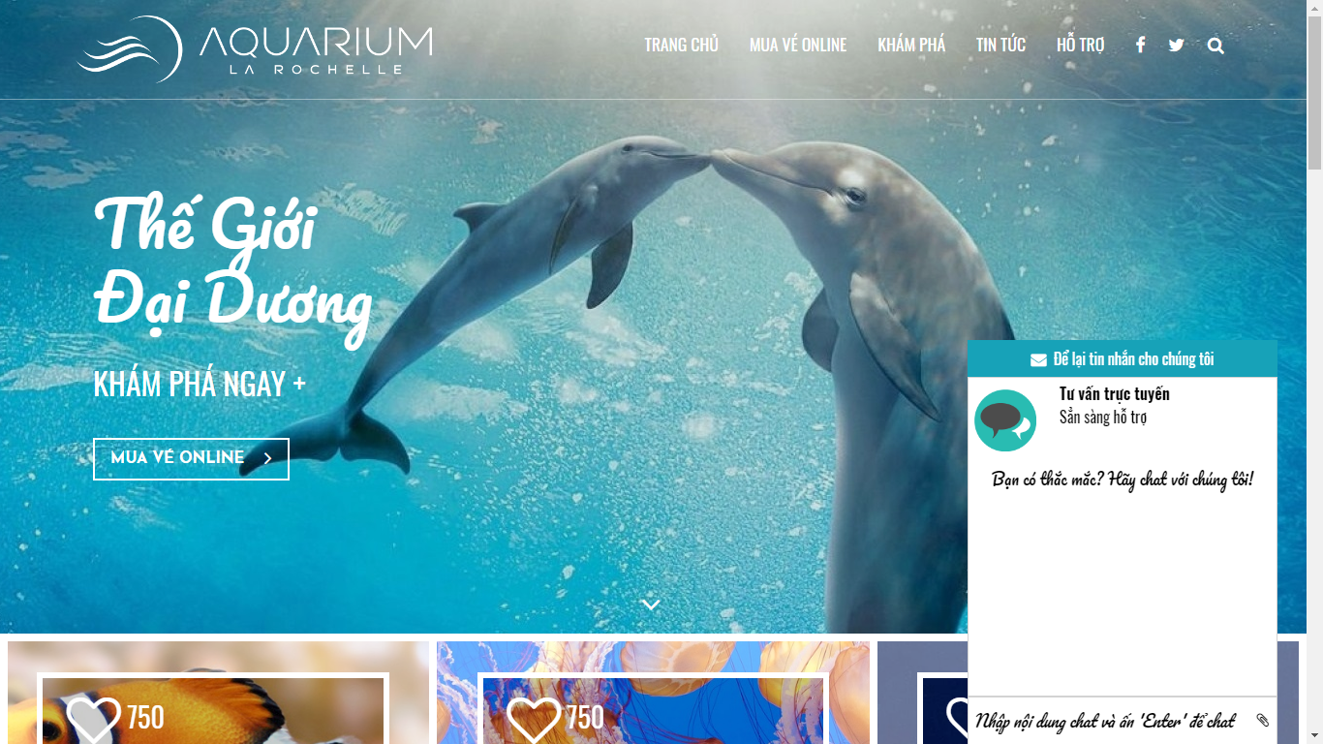

**Contact Online**

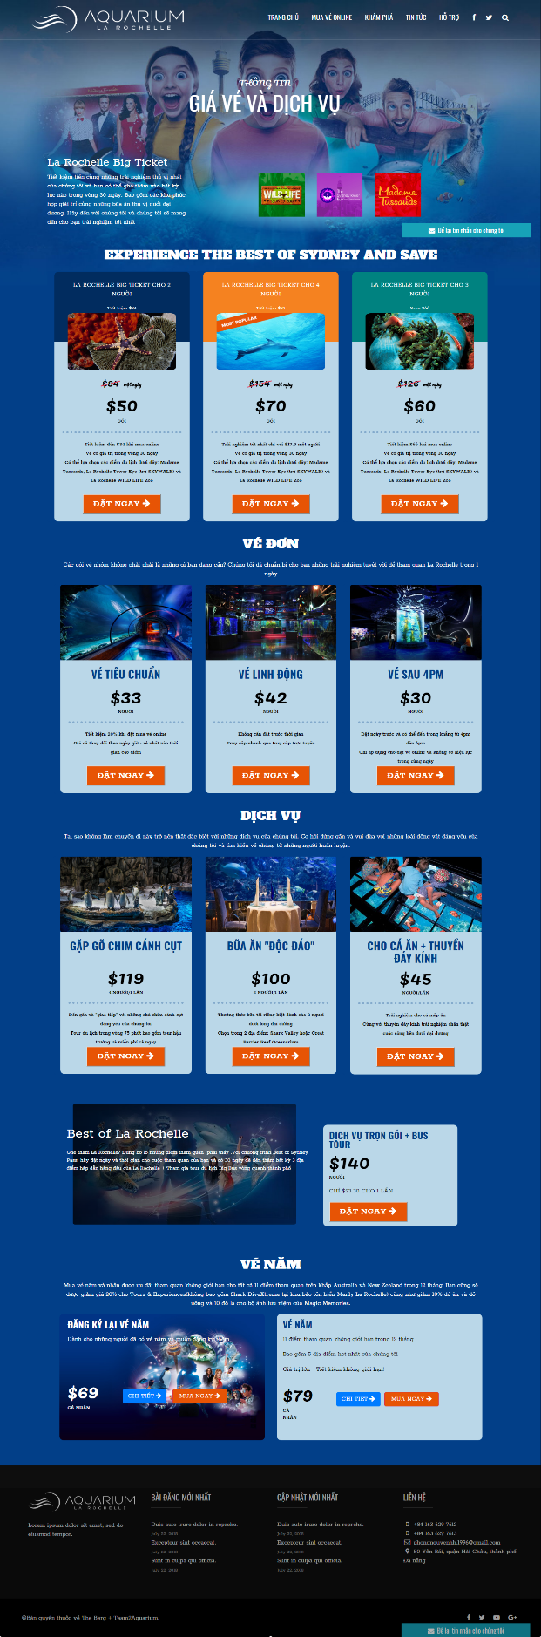

**Buy Ticket**

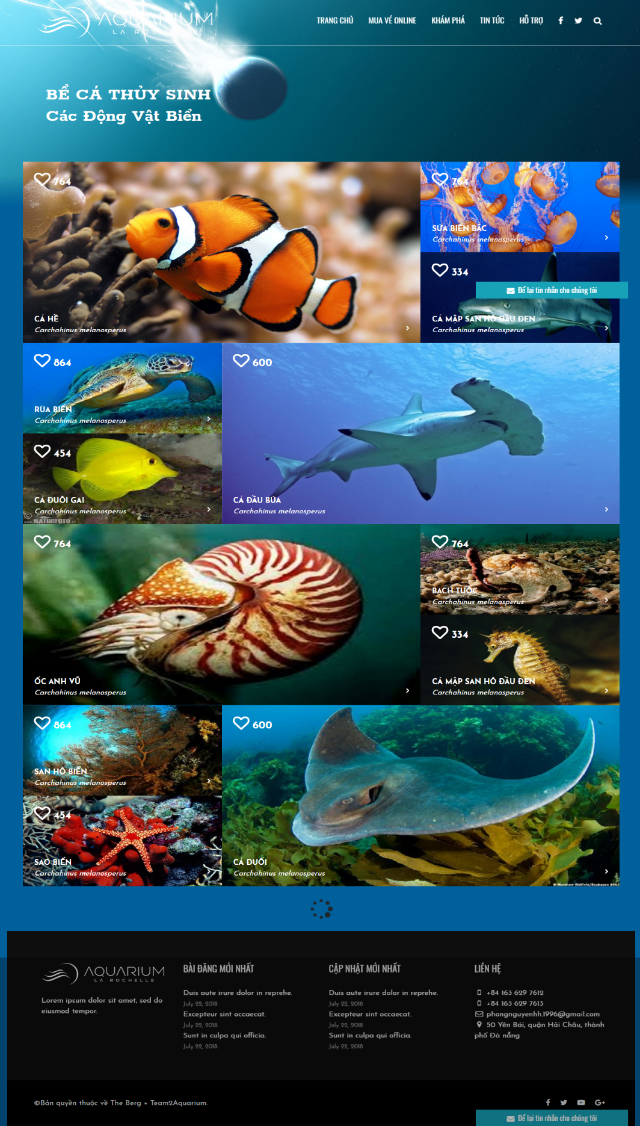

**Discovery**

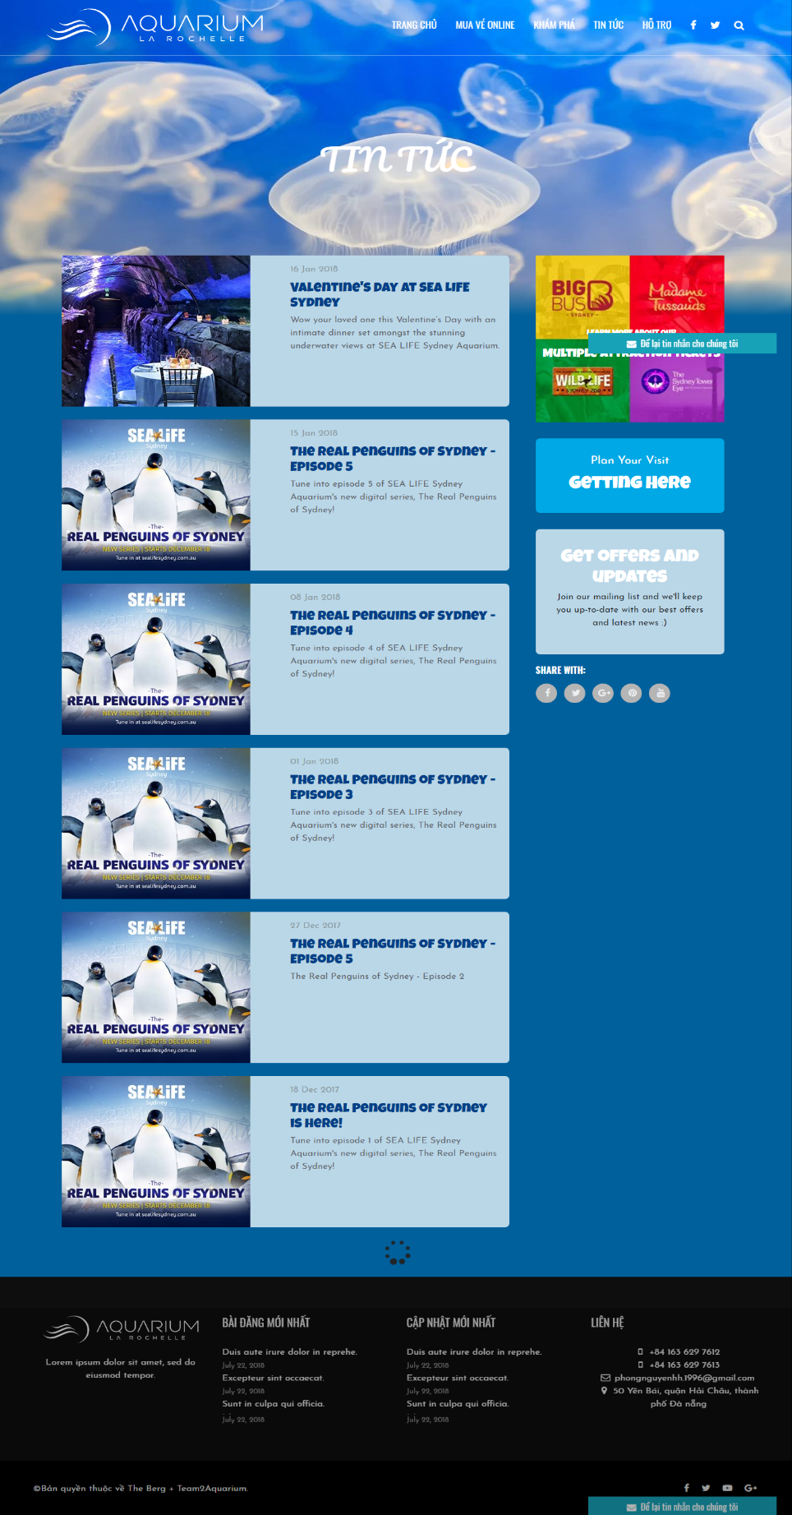

**News**

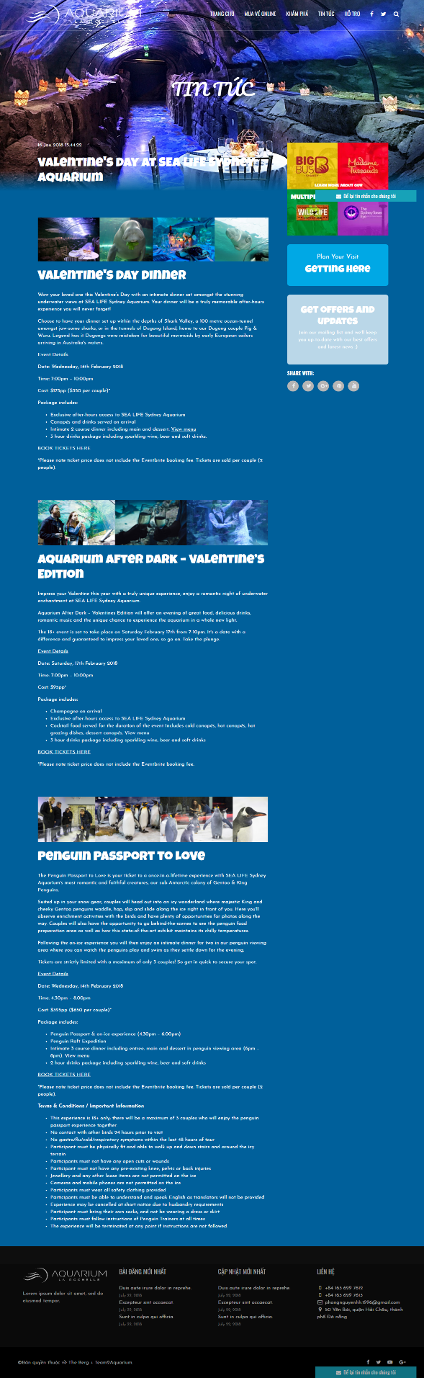

**News Detail**

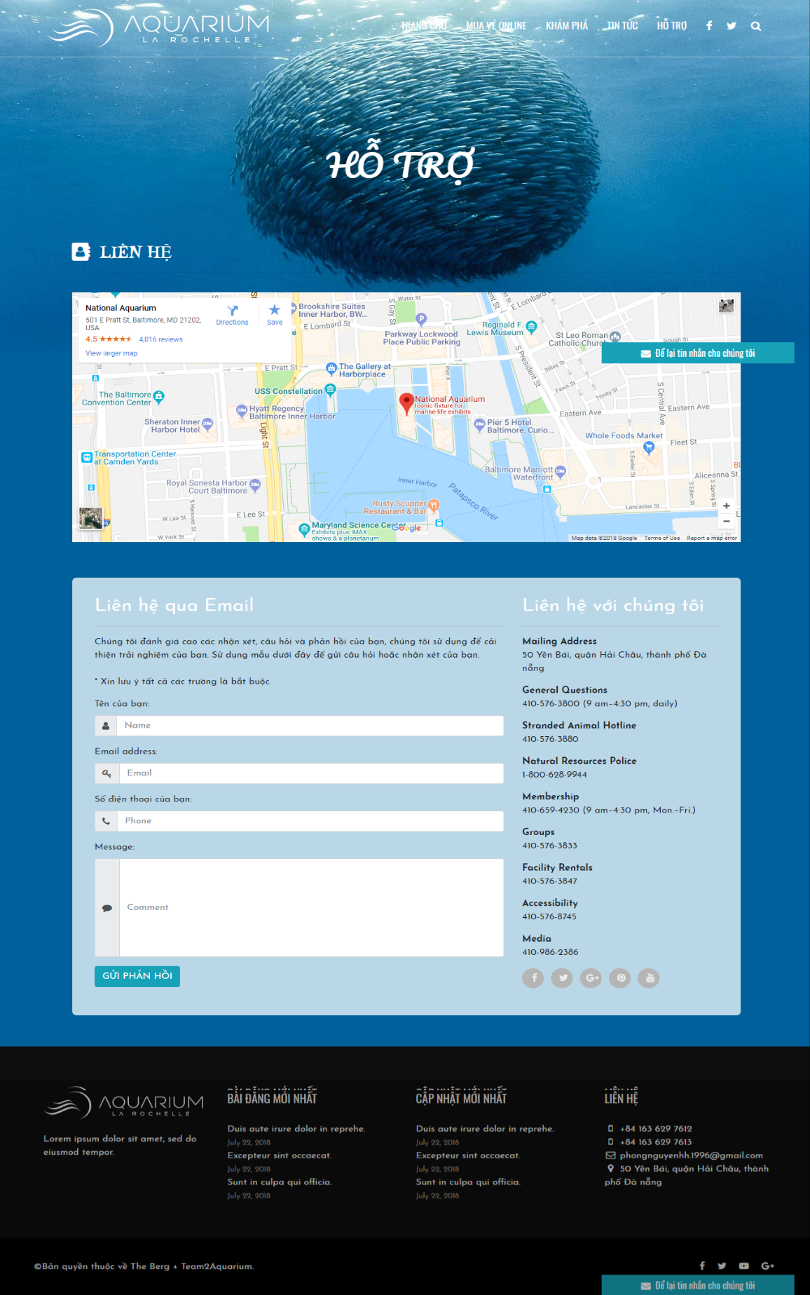

**Contact us**

# X. CHECK LIST

## 1. Check List of Validation

|  |  |
| --- | --- |
| **Option** | **validate** |
| Has the hardware and software been correctly chosen? | Yes |
| Are there functions for the user to enter their comment | Yes |
| Do all the options present in the application display the correct result? | Yes |
| Are there function for the user buy product? | Yes |

## 2. Submission Checklist

|  |  |  |  |  |  |
| --- | --- | --- | --- | --- | --- |
| **No.** | **Particulars** | **Yes** | **No** | **N/A** | **Comments** |
| 1 | Is there a form for users to enter  Personal information when buying  Or put item into the cart |  |  |  |  |
| 2 | Can the user to edit employee’s details after getting added? |  |  |  |  |
| 3 | Is the user able to find a product’s wherever they want? |  |  |  |  |
| 4 | Is the application user-friendly? |  |  |  | Windows GUI is familiar with everyone |

# XI. CONCLUTION

Aquarium website includes: Home page, Discovery, News page, News Detail pages, Contact Us page, Buy ticket and Check Out.

However, this website also need to be develop and upgrated.

Here is the development direction:

1. Complete or perfect remaing parts of this website
2. Change background image and color, font and other as required by the client
3. Develop mobile-optimized website with functions such as: [Website Responsive](https://www.mypage.vn/thiet-ke-web-theo-chuan-mobile.html), [Responsive Design](https://www.mypage.vn/thiet-ke-web-theo-chuan-mobile.html),..
4. Build back-end (Manager/Administrator) for this website
5. Upgrate static website to dynamic website by using java, C#, php, ruby on rails,…
6. Build webApp.